MARRS FALCONS
2025 FALL SPORTS SCHEDULE

GIRLS VOLLEYBALL
8/26 Jamboree @ The Volleyball Academy
9/9 Lewis & Clark
9/11 McMillan
9/16 Beveridge
9/18 Morton
9/23 Buffett
9/25 Hale
9/30 @Norris
10/1 BYE
10/2 King
10/6 Bluestem
10/8 @Davis
10/10 City Finals
@ The Volleyball Academy

CROSS COUNTRY
9/3 @Buffett Invitational
9/10 @Lewis & Clark
9/17 @Bryan Middle Invitational
9/24 @Norris
10/1 @HITCHCOCK PARK (MARRS)
10/7 @Bryan Middle - CITY FINALS
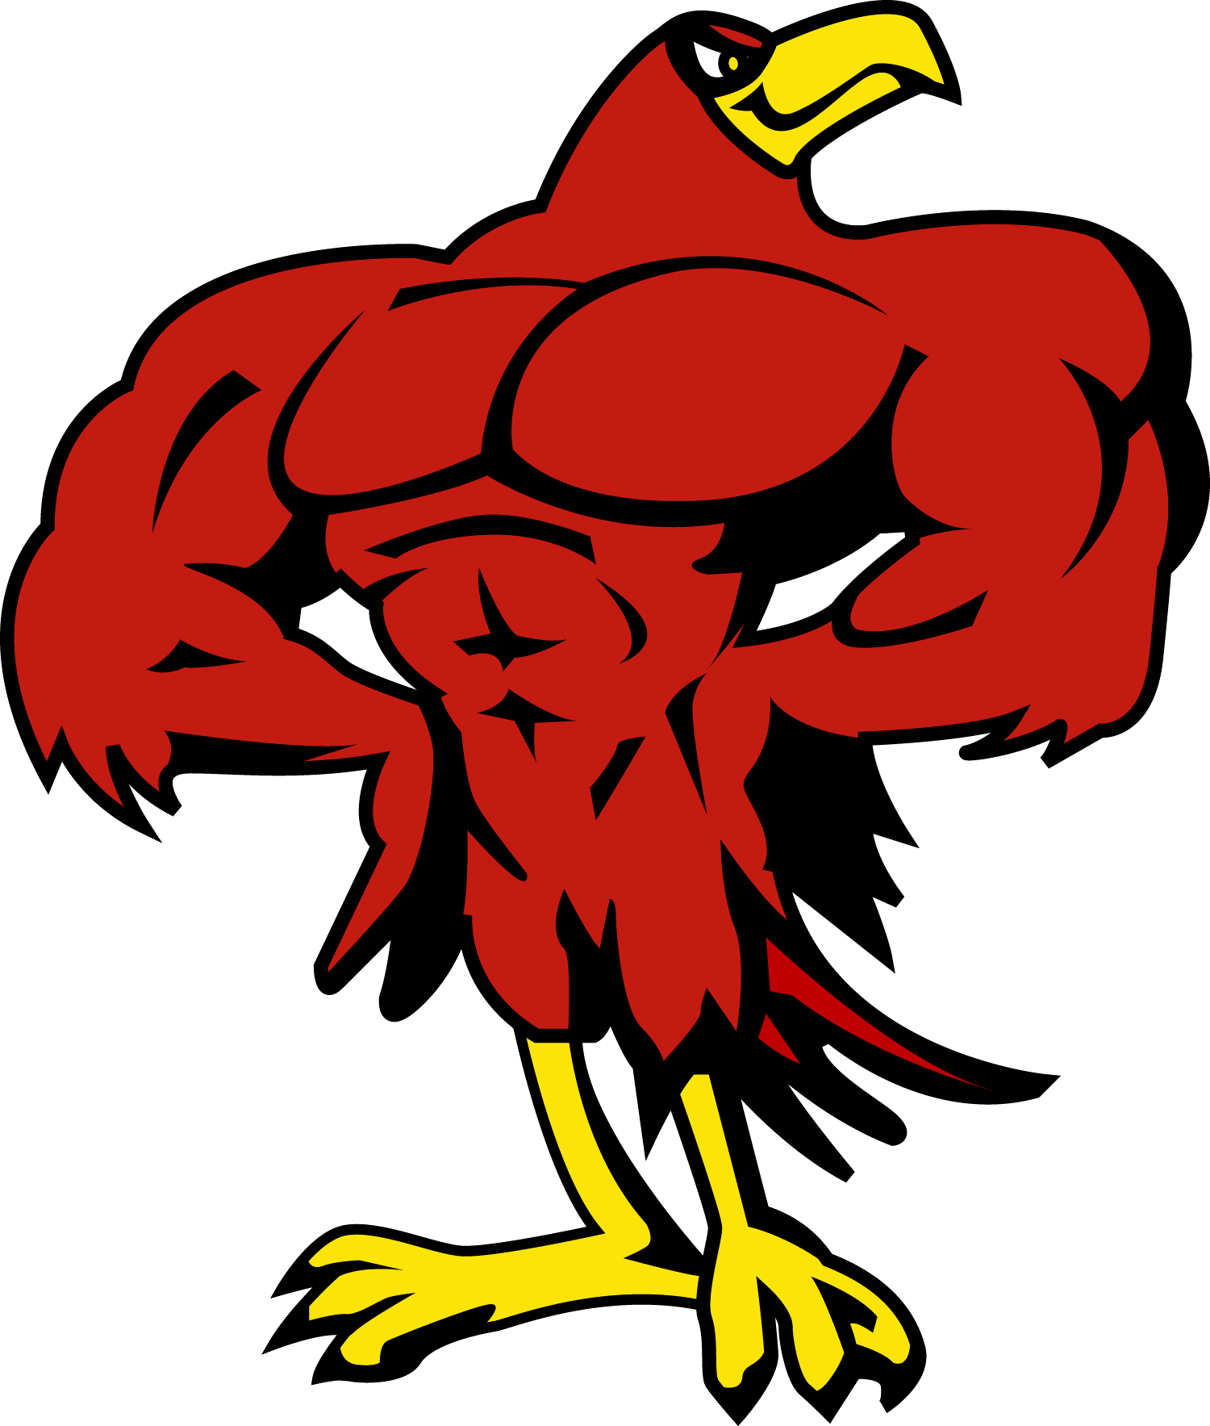

FOOTBALL
9/5 @Buffett JV
9/12 @Lewis & Clark
9/17 @Norris
9/22 @Bluestem
9/26 BYE
10/2 Bryan @ Bluestem
10/9 City Finals @ TBD

